Final Report for XYZ University Website

The problem:

The main objective of the project was to create a university website that is simple and to the point. The problem I tried to solve with this was that a lot of the university websites out there are getting too complicated for a lot of their target users, for example, the parents of their prospective students who might be older and not very technologically literate.

The target audience of this website come from different walks of life. This includes students, who can be as young as 17. These users generally are interested in buying tickets for events that are happening on campus, as well as enrolling in classes for the upcoming semester. Another group that I targeted with the project was parents. I made the website as simple as possible so that parents wouldn’t have any issues. I also kept international users in mind when making this website. To do so, I added a feature on all parts of the website that can translate each page to any language they want.

Design:

I designed this website using HTML. At the top of the website, the name of the university is written in white with a burgundy background. Right below that, there is a navigation bar that has “Home Page”, “Academics”, and “Events” selections listed. Underneath that, the content of whichever page the user is in is displayed, keeping the burgundy color scheme consistent across all pages. Here is a screenshot of the main page:

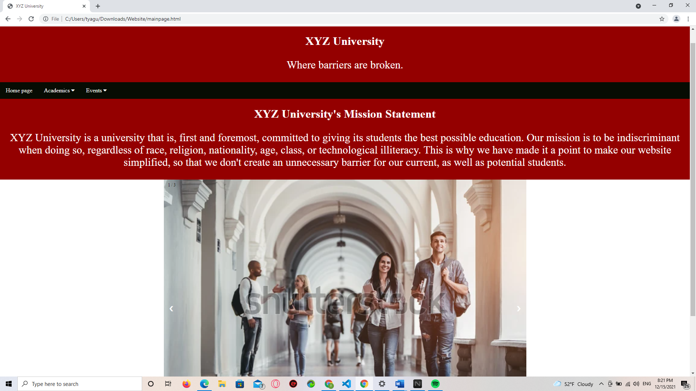

One important decision I had to make was to not keep the design in the sports page where the user could click on a logo to get the table of schedules in the respective sport. I ended up going with a more straightforward design where all the tables are shown with the respective logo on top like this:

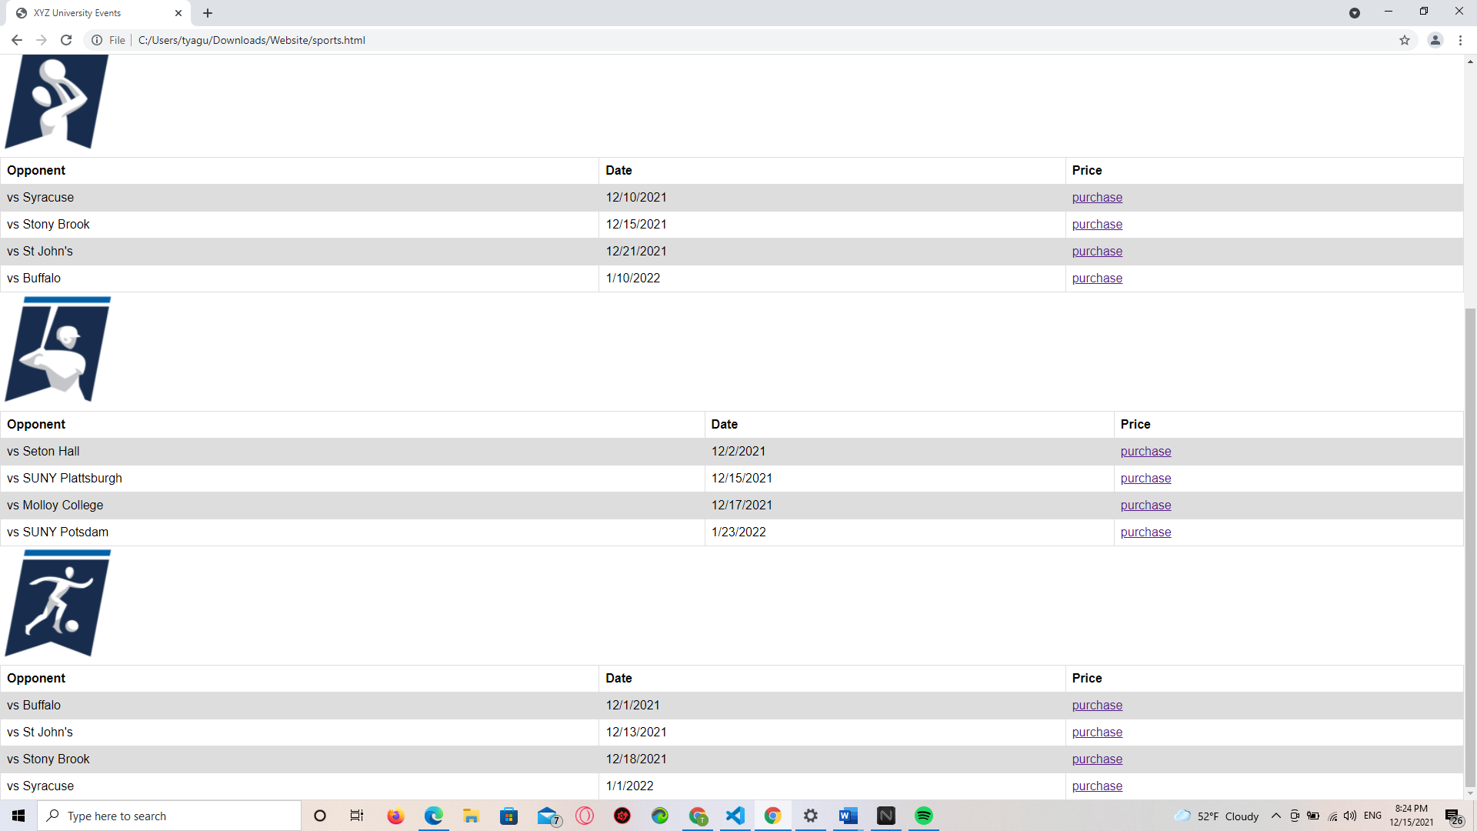

Evaluation:

The main thing I learned from all the rounds of testing was that there is always room to improve, and that listening to the opinions of peers, as well as experts is invaluable to making a better product. After each round of evaluations, the product came out much better than before because I took my peers’ and my professor’s suggestions to heart.

When it comes to some more concrete ways in which I changed things because of what happened in evaluations, the first thing I changed was to add a mission statement to the main page. The second thing that I changed was the sports page that you can see above. Thirdly, I added a description when hovering over navigation bar items. And lastly, I changed the color of the text and the background so that it has better visibility and passes both the WCAG AA, as well as the WCAG AAA tests.

Reflection:

Throughout this process, I learned the value of feedback. The product I had at the start is vastly different than what I ended up with. I also learned that to make the best interface, it is important to look at the requirements, different criteria for good interfaces. For example, I changed the text color and the background color based on the website <https://webaim.org/resources/contrastchecker/>. I also made changes to the website based on Nielsen's Design Heuristics. I will do my best to implement these concepts in my future projects as well, because it has led to great results.

There were also some things that I feel like could be improved. For example, I could keep the sports page like before, where clicking on the logo brings up the respective tables, but just does so in a neat way. I could also have more appropriate confirmation and error messages. The main obstacles to these were my HTML skills, as well as the time limitations.

If I were to redo this project, the first thing I would have done differently would have been to take the prototyping stage more seriously. I did not do a sketch for the project, and I didn’t use a prototyping tool such as Adobe XD. When it came to the prototyping stage, I jumped straight to writing code in HTML, which wasn’t the best idea. If I had done appropriate prototyping procedures, visualizing how the website should look would have been easier.